SendGrid

💡 What is SendGrid?
# Source: AI Source: Provided by: [Data Path: Persons Table -> ID Column: 1, Name_En Column: Motasem Essam] -> From: [Chatgpt (GPT‑5 Mini)] on [1/21/2026]
SendGrid is a cloud-based email delivery service that allows developers and businesses to send emails at scale — like:
- ✉️ Transactional emails (e.g., password resets, order confirmations)
- 📢 Marketing emails (e.g., newsletters)
- 📈 Analytics and deliverability tracking
It's often used as an alternative to Gmail SMTP, Amazon SES, or Mailgun — especially when you want high deliverability, email analytics, and scalability.

🔧 Key Features of SendGrid
# Source: AI Source: Provided by: [Data Path: Persons Table -> ID Column: 1, Name_En Column: Motasem Essam] -> From: [Chatgpt (GPT‑5 Mini)] on [1/21/2026]
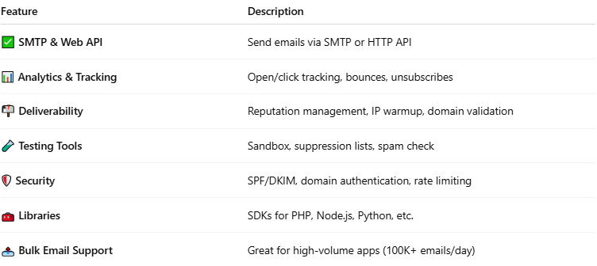

Feature | Description
✅ SMTP & Web API | Send emails via SMTP or HTTP API
📊 Analytics & Tracking | Open/click tracking, bounces, unsubscribes
📬 Deliverability | Reputation management, IP warmup, domain validation
🧪 Testing Tools | Sandbox, suppression lists, spam check
🛡️ Security | SPF/DKIM, domain authentication, rate limiting
🧰 Libraries | SDKs for PHP, Node.js, Python, etc.
📤 Bulk Email Support | Great for high-volume apps (100K+ emails/day)

✅ Free Plan (As of 2024)
# Source: AI Source: Provided by: [Data Path: Persons Table -> ID Column: 1, Name_En Column: Motasem Essam] -> From: [Chatgpt (GPT‑5 Mini)] on [1/21/2026]


Plan | Limit
Free Tier | 100 emails per day (via API or SMTP)
Paid Plans | Start from $19.95/month for 50,000+ emails

📡 How You Can Use SendGrid in PHP
# Source: AI Source: Provided by: [Data Path: Persons Table -> ID Column: 1, Name_En Column: Motasem Essam] -> From: [Chatgpt (GPT‑5 Mini)] on [1/21/2026]
You can either:
- Send email via SMTP (like Gmail)
- Or send via Web API (faster, better tracking)

📦 Example: SendGrid via SMTP (using PHPMailer)
# Source: AI Source: Provided by: [Data Path: Persons Table -> ID Column: 1, Name_En Column: Motasem Essam] -> From: [Chatgpt (GPT‑5 Mini)] on [1/21/2026]
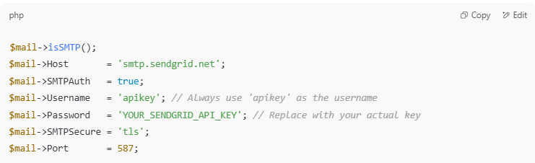

$mail->isSMTP();
$mail->Host = 'smtp.sendgrid.net';
$mail->SMTPAuth = true;
$mail->Username = 'apikey'; // Always use 'apikey' as the username
$mail->Password = 'YOUR_SENDGRID_API_KEY'; // Replace with your actual key
$mail->SMTPSecure = 'tls';
$mail->Port = 587;

✅ This works just like Gmail, but more scalable and professional.

🔐 How to Get Started
# Source: AI Source: Provided by: [Data Path: Persons Table -> ID Column: 1, Name_En Column: Motasem Essam] -> From: [Chatgpt (GPT‑5 Mini)] on [1/21/2026]
- Sign up at: https://sendgrid.com
- Go to Settings → API Keys
- Generate a key (full access or restricted)
- Use it as the password in your SMTP setup or Web API call

📬 SendGrid vs Gmail SMTP
# Source: AI Source: Provided by: [Data Path: Persons Table -> ID Column: 1, Name_En Column: Motasem Essam] -> From: [Chatgpt (GPT‑5 Mini)] on [1/21/2026]
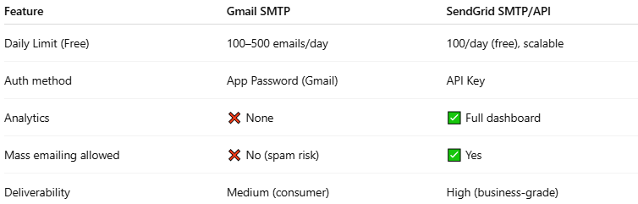

Feature | Gmail SMTP | SendGrid SMTP/API
Daily Limit (Free) | 100–500 emails/day | 100/day (free), scalable
Auth method | App Password (Gmail) | API Key
Analytics | ❌ None | ✅ Full dashboard
Mass emailing allowed | ❌ No (spam risk) | ✅ Yes
Deliverability | Medium (consumer) | High (business-grade)

🧠 Summary
# Source: AI Source: Provided by: [Data Path: Persons Table -> ID Column: 1, Name_En Column: Motasem Essam] -> From: [Chatgpt (GPT‑5 Mini)] on [1/21/2026]
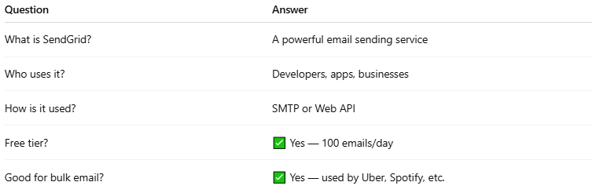

Question | Answer
What is SendGrid? | A powerful email sending service
Who uses it? | Developers, apps, businesses
How is it used? | SMTP or Web API
Free tier? | ✅ Yes — 100 emails/day
Good for bulk email? | ✅ Yes — used by Uber, Spotify, etc.

Would you like a SendGrid + PHP/PHPMailer sample script you can plug into your app?

